Thursday Bidding Tips 8 Board 5 played on 14/6/2018 Horowhenua Pairs
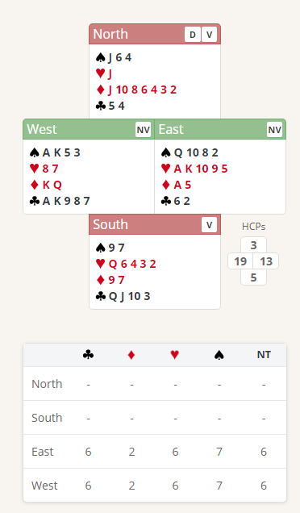
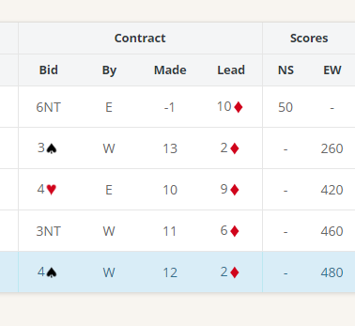

Suggested Bidding 1
N Dealer | E | S | W
Pass | 1H | Pass | 1S
Pass | 2S | Pass | 4NT
Pass | 5H | Pass | 5NT
Pass | 6D | Pass | 6S
Pass | Pass | Pass

- Easts bid of 1 Heart shows 12-19 points and at Least 4 Hearts.
- Wests reply of 1 Spade shows 6+ points and 4 Spades
- East with 4 Spades bids 2 Spades to show support
- West with 20 points (19High Card points and 1 for Doubleton Heart) Knows there is at least 32 points so makes a Blackwood Ace Ask of 4 No Trumps
- East with 2 Aces bids 5 Hearts
- West now knows that all 4 Aces are in the EW Hands and makes a Blackwood King ask of 5 No Trumps
- East with 1 King bids 6 Diamonds
- West now knows that all 4 Aces and 4 Kings are in the EW Hands and bids a slam of 6 Spades (8 Card Fit)

Suggested Lead from North 6 Diamonds (4th Of longest Suit) or Singleton Jack Hearts

Further notes about Blackwood slam bidding http://www.nzbridge.co.nz/user/inline/1794/NZB%20Improver%2002%20-%20Student%20Notes.pdf

